# CCX MD vs CMD Summary and Test Program

## Summary

Substantial differences are observed when testing first crack in the CMD vs MD direction.

Based on first crack (cement thickness only – see ASTM D8058 Performance Comparison Data):

1. Extrusion samples (these were run at 3m/min and had low density. The difference went from 27% down to 13% post coating, nip pressure may have been up to 2MPA but was probably lower. Md 1st crack went from 4.2 to 4.8MPa.
2. For upper quartile CCX the difference is 50% and MD 1st crack is 11.6MPa
3. For laminated samples (2m wide) the nip pressure is calculated at 1MPa and the control was 34% which decreased to 25%. MD 1st crack increased from 9.1 to 10.6MPa.

In 191219 CX0212191102-01 Samples of CCX were compressed between steel platens at 2MPa.

1. First crack MD was only 3.82 for controls indicating the material was poorly filled.
2. It was observed that the difference was only 9% CMD to XMD but increased to 80% for the compressed samples. The Md 1st crack increased to 9.19MPa so rose to a similar level to well filled samples.
3. The CMD decreased in compressed samples by a factor of up to 2

Observation

Samples show circular speckles (almost certainly sand grains) that correspond with the location of the tubes, there aren’t specks outside these tubes. In some areas there are lozenged shaped across two or three tubes. The CMD cracks form between these tubes, they formed preferentially between tubes before cracking between lozenges. This was repeated using samples from both sides of the cut.

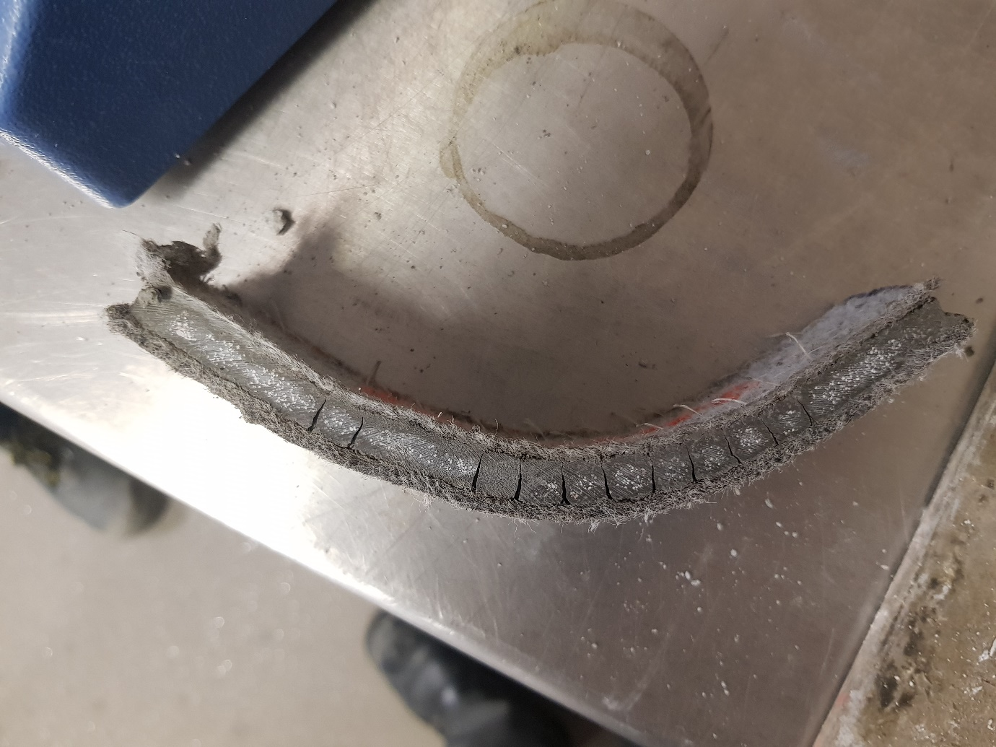

## Hypothesis for difference between CMD and MD

**H1: Caused by yarns**.

* 1. yarns cause a reduction in the cross section of the set cement
  2. The yarns create a stress raiser where cracks initiate.

**H2: Caused by the sand being located only in the tubes**

2.1 there is only cement bridging between tubes and this is weaker than the sand cement areas

2.2 the presence of the sand indicates a region of higher density and this accounts for a higher strength region.

**H3: Caused by rollers/platens only acting on the top of the bumps creating regions of very high density between the bumps but not in the troughs.** The drop in CMD strength following compression was as a result of the material between the bumps increasing in strength and stiffness rather than a decrease in density and strength of the material between the tubes and this led to an increased local stress.

**H4: Caused by a difference in Cross sectional Area**

**H5: The difference will decrease with increasing cure time**

## Actions to test the Hypothesis

Measure basis weight (kg/sqm) for all samples prior to testing.

**H1: Caused by yarns**.

ACP – Measure the cross section of the cement and yarns on the failure surface using a microscope and try to determine if the difference in strength is related to the relative areas.

AMS – modify CX01 (synchronised take down roller) to increase the stitch length ideally to at least 15mm, this will have the advantage of reducing the friction for the thinner CCX. Increased risk of prolapse can be compensated by stronger yarns if necessary.

ACP – test samples cut at 4 degrees to the MD.

ACP – test to see if this changes the MD CMD gap.

**H2: Caused by the sand being located only in the tubes**

ACP – Check results (ask CE) from previous narrow width testing to see if difference between R cement only and 75/25 blend accounts for difference. – this could confirm 2.1

[S:\NEPR-2017-07\CX02 - Production Line\CX02 Operating Information

191101 CX02 Production Records

One can find the sample ID and the operational parameters in this spreadsheet

CX02 Analytical Records

The sample ID can be used in this spreadsheet to look up the testing results]

ACP – test recent production (19/12/19) of thin and med thickness CCX samples in MD and CMD direction (NB samples in CMD direction will include some thicker material but this is probably ok as long as the centre of the sample where the first crack forms is thin (thin section is 140mm wide). Examine these samples for the sand distribution. - Potentially the distribution will be different for thinner samples and this may correlate with relative MD/CMD results.

ACE – test samples with and without speckles from the same set bar using XRD to look at relative silica/cement peaks to confirm if speckles are sand or a harder phase of the set cement.

**H3: Caused by rollers/platens only acting on the top of the bumps creating regions of very high density under the bumps but not the troughs.**

AMS – Run a sample of good CCX and take control sample then sample run with pinch open (uncompressed).

CP – compare MD and CMD for above.

CP – Using good material conduct 6 tests crushing square samples in the plattens + control, comparing CMD and MD results:

1. 2MPa – both between steel and between thick(>30mm) rubber/foam pads on both surfaces
2. 4MPa – both between steel and between thick(>30mm) rubber/foam pads on both surfaces
3. Max Pressure– both between steel and between thick(>30mm) rubber/foam pads on both surfaces

The rubber should reduce the effect of pressure concentration on the peaks.

**H3.1 – the powder within made samples can be redistributed after manufacture and this will affect the MD CMD performance.**

1. Vibrate a sample for 30s at 200hz
2. Roll a sample around a tube approx. 60mm diameter in both directions twice and then compare MD and CMD results as well as with a control.

**H3.2 – compression with rollers for a given pressure has the same effect as compression with platens**

1. Use the pinch on the CCX line to compress samples and roll them:
   1. Calculate sample pressure for 2m rolls. (ask Mark)
   2. Use narrower sample to create higher pressures. Run the sample through with the tricot against the rubber coated roller.
      1. 2 Bar
      2. 4 Bar

*Following the above repeat with rubber only on the tricot side. This is something we could repeat with the laminator and retain the density increase.*

ACP – Test 300mm wide samples from Laminator trial, these samples saw calculated nip pressures of 6.5MPa the samples tested already were 2.0m wide and saw only 1MPa. Laminator nip rollers were rubber coated.

**H4: Caused by a difference in Cross sectional Area**

ACP – accurately measure cross sectional areas for good tested samples in the MD and CMD and calculate MPa equivalent more precisely.

**H5: The difference will decrease with increasing cure time**

ACP - Test sample at 14Days.